A Systematic Review of Innovative Technologies for Enhancing Autonomy in Adults with Intellectual Disabilities

Introduction
The World Health Organization (WHO) define that the intellectual disability is a developmental condition characterized by much lower than usual intellectual functioning and limitations in adaptive skills such as writing, reading, problem-solving, or decision-making. The United Nations, within the framework of the Sustainable Development Goals, emphasizes the need to address ongoing barriers to the inclusion and participation of Persons with Disabilities (PwD) in communities. The main barriers identified include discrimination and stigma, lack of accessibility to both physical and virtual environments, limited access to assistive technologies and rehabilitation services, and limited opportunities for independent living that would enable agency and transformative opportunities for PwD (Guterres, A. 2018). Similarly, the Convention on the Rights of Persons with Disabilities, ratified in Colombia through Law 1346 of 2009, mandates that "it is necessary to ensure that persons with disabilities enjoy human rights and freedoms without discrimination" and acknowledges that disability is the result of interactions between individuals and societal barriers that inhibit or prevent societal participation (González Martín N, 2008).
Since the 1990s, there has been a substantial change in how we define disability. Previously focused on deficits and viewing PwD as victims, the modern view sees people with disabilities as individuals with rights involved in complex interactions between health, economic, and socio-political factors (Stang Alva M, 2011). This perspective has given rise to a biopsychosocial approach to disability, which views the condition through biological, personal, and social dimensions (Toboso Martín, M & Arnau Ripollés, M. 2008).
The United Nations' disability inclusion strategy highlights the urgent need to employ technology to enhance inclusion and accessibility for people with disabilities. This strategy aims to reduce the digital bridge and expand access to assistive technologies, essential yet often inaccessible for most PwD in many countries (Meetings Coverage, 2024). The Conference of States Parties (COSP) to the Convention on the Rights of Persons with Disabilities has underlined the importance of technological innovation in creating accessible futures and the necessity of international cooperation to accelerate innovation and technology transfer (UN DESA Voice, 2024). For example, in Indonesia, UN staff have been trained on maintaining accessibility standards in daily tasks and have committed to enhancing accessibility in their internal operations, demonstrating a practical approach to greater digital inclusion (United Nations DCO, 2024).
The literature on assistive technology for adults with intellectual disabilities identifies several significant gaps, particularly in developing these technologies for adult life stages. A major deficit is the limited consideration of the specific needs of adults with intellectual disabilities in terms of access to appropriate assistive products. This group often remains disadvantaged and stigmatized, exacerbating their health situations and limiting their access to essential services and products. The high prevalence of comorbidities in this group underscores the need to effectively manage these conditions with the support of assistive technologies (Boot, F. 2017). Furthermore, the literature tends to focus on technologies that enhance basic "functional capabilities," such as communication and mobility, but often overlooks the potential for technologies that could significantly enhance human functionality in everyday contexts and improve quality of life. This includes everyday technologies such as smartphones and other telecommunications devices, which could be adapted to improve inclusion and autonomy for people with intellectual disabilities in inclusive environments (Wehmeyer, M.L. 2020).
While many studies concentrate on childhood or introducing technologies that improve basic functional capabilities like communication and mobility, this review emphasizes the transition to adult life, a phase less explored in the existing literature. This approach seeks to fill a critical gap by considering how technologies can support ongoing development and autonomy in more advanced life stages (Marinaci, T. 2023) (cciadmincca1. 2020). Furthermore, the exploration of graphical interfaces and social robots combined with artificial intelligence represents a novel direction compared to studies discussing conventional technological aids for mobility or communication. This approach aims to assess how these advanced technologies can transform quality of life and promote greater independence (Owuor, J. 2018) (Wehmeyer, M.L. 2020).
This review aims to explore how technological innovations, particularly the use of graphical interfaces combined with social robots and artificial intelligence, can play a transformative role in improving the autonomy and quality of life of people with intellectual disabilities, especially during their transition to adulthood. Studies documenting the benefits of these technologies in developing independent living skills and their impact on the transition of young people with intellectual disabilities to adulthood will be analyzed.
This review is organized into four sections: introduction, methodology, discussion and results and conclusions. The methodology describes the process used to search for and select articles and information, where inclusion and exclusion criteria were applied, in addition to using a variety of filters and criteria to ensure the inclusion of relevant studies and the robustness of the analysis. Likewise, in the third section, the results are presented, offering a detailed description of the findings obtained through the exhaustive analysis of the selected studies. In the discussion section, the interpretation of the results is explored by exploring both the theoretical and practical implications derived from the findings. Finally, the study's conclusions synthesize the analysis conducted, summarizing the main findings and highlighting the significant contribution and relevance of the research to the field of study.

Methods
To carry out the systematic review, the PRISMA methodology was used. This methodology was developed by a group of 29 review authors, methodologists, clinicians, medical editors, and consumers (Moher D, 2008). PRISMA focuses on ways in which authors can ensure the transparent and complete reporting of systematic reviews and meta-analyses. It does not address directly or in a detailed manner the conduct of systematic reviews, for which other guides are available.
Within this methodology, the PRISMA checklist was implemented to identify the key aspects that the article should have. The Flow Diagram of study selection was also used to graphically observe the filters and step-by-step selection of the articles (Liberati A, 2009).
2.1 Literature Search
A systematic literature search was conducted across various academic databases,
specifically Scopus, PubMed, LENS, and Semantic Scholar, to identify studies investi-
gating the application of robots and artificial intelligence algorithms in the education
and training of individuals with intellectual and developmental disabilities, particu-
larly focusing on daily living activities. The search equation that was utilized is on
the figure 1.
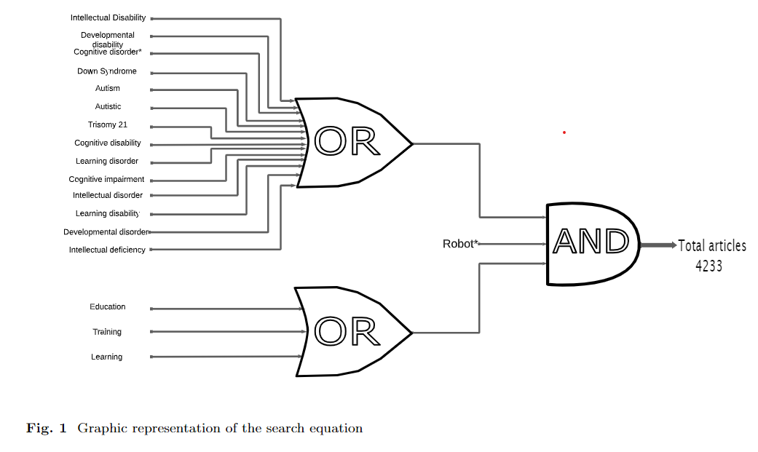
Robot* AND (”intellectual disability” OR ”developmental disability” OR ”cogni-
tive disorder*” OR ”autistic” OR ”autism” OR ”down Syndrome” OR ”trisomy 21”
OR ”cognitive impairment” OR ”cognitive disability” OR ”learning disability” OR
”developmental disability” OR ”developmental disorder” OR ”intellectual deficiency”
OR ”learning disorder” OR ”intellectual disorder”) AND (education OR training OR
learning).
Additionally, a parallel search was conducted in Spanish using the same equation
across the same databases. This bilingual approach broadened the study’s scope,
incorporating diverse perspectives and findings from various linguistic and cultural
backgrounds.
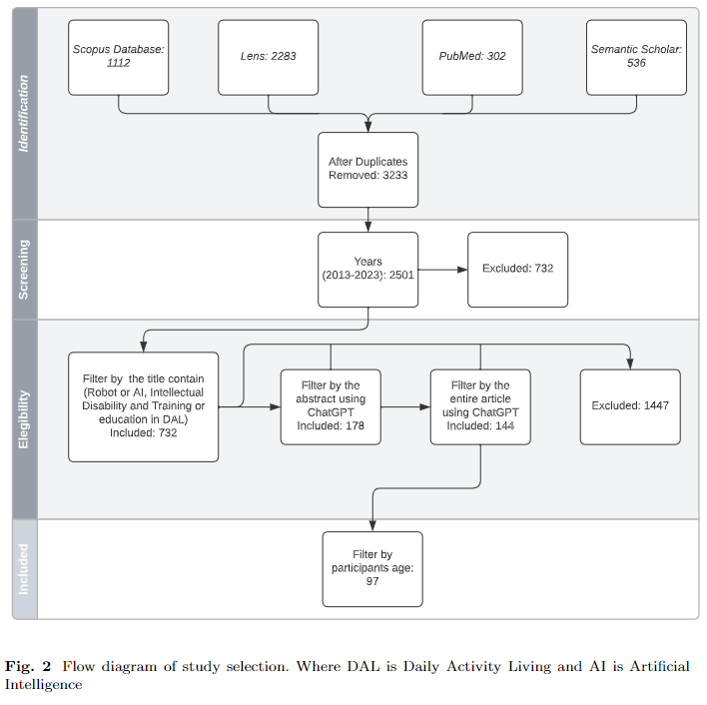
2.2 Study Selection
The initial phase of study selection involved the removal of duplicate entries. This was
carefully performed using Excel through several techniques to ensure the accuracy of
the review process:
1. DOI Search: Identifying and removing articles with repeated DOIs, as these are
unique identifiers for each publication.
2. Exact Title Match: Eliminating articles with titles that were the same,
ensuring that only unique studies were considered.
3. Title Transformation: Applying a macro to transform titles by removing special
characters and converting all letters to lowercase. This step helped identify titles
that were the same but appeared different due to formatting variances.
4. Manual Validation: Finally, a manual review of the remaining duplicates was con-
ducted, focusing on entries where titles included the journal name at the beginning,
which might have been missed by the automated processes.
Following the duplicates removal, an additional filter was applied to only consider
articles published within the last decade (2013-2023), aligning the review with the
most recent findings.
2.2.1 Title Filter
Next, a preliminary filtering based on the study titles was carried out manually for all
articles by two different members of the team to reduce individual bias. In this filter,
the title was evaluated to ensure it was related to robots or artificial intelligence,
intellectual disability or synonyms, and training or education in daily living activities.
The process was carried out in Excel by using a column to check each term, and in
the end, only those articles that had all 3 columns completed were selected to proceed
in the review process.
This approach ensures thorough methodology, minimizing bias and including high-
quality research on robots and AI for individuals with disabilities in daily activities.
2.2.2 Abstract Filtering
A comprehensive analysis of abstracts was conducted using ChatGPT to address key
questions regarding the implementation of social robots or artificial intelligence, the
target population, and the focus on daily living activities, training, education, or
learning. The following questions were employed:
1. Is there any social robot or artificial intelligence used?
2. Is there the target population individuals on the autism spectrum or with some
intellectual disability?
3. Are there exercises related to activities of daily living, training, education, or
learning conducted?
The responses generated by ChatGPT were entered into an Excel table to validate a
random sample of approximately 60% of the articles manually. This validation process
aimed to verify the accuracy of the results and to select those articles that received
a positive response to all three questions. Only articles meeting these criteria were
selected for further review.
2.2.3 Full-Text Analysis
For a deeper understanding, ChatGPT examined the full text of pre-selected studies,
focusing on the types of robots or AI algorithms, the ages of subjects, and the types
of intellectual disabilities addressed. Each article was analyzed with the following
questions:
1. What was the type of robots or AI algorithms involved?
2. What were the ages of the subjects involved in the study?
3. What were the types of intellectual disabilities of the subjects involved in the study?
In this case, a manual validation of 60% of the articles was also conducted. Excel
was used to store the responses to the questions, ensuring that all responses were consistent. After this validation, a manual consolidation of terms was performed. In the column related to robots, it was specified whether it was a Social Robot or a Social
Robot with AI. In the next column, the age of the participants was classified as Chil-
dren, Teenagers, Younger Adults, Adults, Older Adults, or Not Specified Age Range.
In the last column referring to the type of intellectual disability, it was classified as
Autism Spectrum Disorder (ASD), Intellectual Disability, Mild Cognitive Impairment,
and Others.
Based on this classification, articles related to Adults, Older Adults, and No Spe-
cific Age Range were eliminated. This process resulted in a final selection of 97 articles
for further analysis. A graphical representation of the applied filter is shown in the
figure 3.
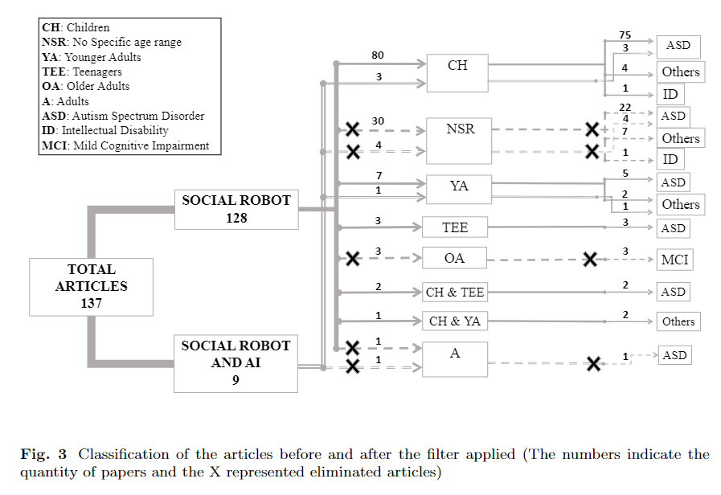
This structured and detailed methodology ensures a comprehensive and systematic
review of the existing literature in the field of study. By employing both manual
and artificial intelligence-assisted analysis, the precision and relevance of the selected
studies for this review were maximized.
2.3 Extract Information
To extract information from the selected articles, a series of global questions was created, focusing on the technologies used, the skills to be developed in users, the protocols used, etc. From these questions, several sub-questions were derived to obtain more detailed information. The formulated questions are found in Table \ref{tab:my-table}. After this, ChatGPT 4 was used to analyze the complete text and provide answers to each of the questions posed. The answers were stored in an Excel file after two group members manually verified approximately 60\% of the responses against the original articles to ensure the information provided by ChatGPT 4 was accurate.

Subsequently, the information was divided into different Word files, each containing the answer to each sub-question for the 97 selected articles. After organizing the information into Word files, each sub-question was sent in three prompts to Claude 3.5 Sonnet, requesting a summary of the answers. Finally, all responses generated by Claude 3.5 Sonnet were verified by two members of the research group, first confirming that the response included the same number of articles that were sent, and then validating that the information matched what was stored in each of the files.

